**LAB # 03**

**Working with MS- POWERPOINT**

## **Introduction**

Microsoft PowerPoint is a slide show presentation program currently developed by Microsoft. PowerPoint initially named "Presenter", was created by Forethought Inc.. Microsoft's version of PowerPoint was officially launched on May 22, 1990, as a part of the Microsoft Office suite. PowerPoint is useful for helping develop the slide-based presentation format and is currently one of the most commonly-used presentation programs available.

EXAMPLE # 01: Using PowerPoint to create a presentation

**Create a Power point presentation as specified:**

* Title page
  + Slide Layout should be “Title Slide”
  + Heading: “Communication Media”
  + Add your name in a Text Box. Centered at the bottom of the slide
* First slide
  + Slide Layout should be “Title and Content”
  + Title: “Types of Communication Media”
  + Text: Wired and Wireless (In bullets)
  + Place picture in front of each type
* Second slide
  + Title: “Wired”
  + Define Wired Communication Media (In Bullets)
  + Write Examples: Telephone Network, Cable Television, Internet Access, Fiber-Optic communication, Wave guide
* Third Slide – Seventh Slide
  + Title: “Example Of Wired Communication Media”
  + Define Telephone Network, Cable Television, Internet Access, Fiber-Optic communication, Wave guide
  + Add one picture and at least three points about each example
* Fourth Slide
  + Title: “Wireless”
  + Define Wireless Communication Media(In Bullets)
  + Write Examples: Infrared, Microwave, Bluetooth, Communication Satellite, Radio Transmission
* Fifth Slide – Thirteenth Slide
  + Title: “Example of Wireless Communication Media”
  + Define Infrared, Microwave, Bluetooth, Communication Satellite, Radio Transmission
  + Add one picture and at least three points about each example
* Sixth Slide
  + Create a Summary
* The background color of each slide should be different
* Add transition to all slides (Same for all slides)
* Add animations to the text
  + Apply “Fade” animation for the title of each Slide
  + Apply any other animation on the remaining text

Example # 02: Using Action Buttons to create a nonlinear presentation

**Create a Power point presentation as specified:**

* Make a simple four-slide show.
* Use the **Title Only** layout and move the title to the middle of the slide.
* Place a title on each slide corresponding to the number of the slide (Slide One, Slide Two...).
* Give each slide background a different color.
* SLIDE 1:
  + Add a button in the bottom right corner of this slide to allow us to jump to slide two.
* SLIDE 2:
  + Add a button in the bottom right corner of this slide to allow us to jump to slide three.
  + Create a button in the bottom left corner of this slide to go back to slide one.
* SLIDE 3:
  + Add a button in the bottom right corner of this slide to allow us to jump to slide four.
  + Create a button in the bottom left corner of this slide to go back to slide two.
  + Add a third button in the middle at the top of the slide. This will be a hyperlink to an Internet page.
* SLIDE 4:
  + Insert a button in the middle of this slide, back to the first slide. Choose the button with a house on it, as a link to the Home slide.

Example # 03: Using Invisible Buttons in a PowerPoint Slide Show

**Create a Power point presentation as specified:**

* Find a good picture that has elements that you want to feature in your PowerPoint show.
* On the first slide, insert the picture you plan to use and resize it so the picture covers most, or all, of the slide.
* Identify how many action buttons you have to add in the slide. Add the same number of slides in your show.
* Put something in the **title** area of each slide to identify the content of the slide. (You will need these titles to link your action buttons to the slides)
* Over each picture, place action buttons that will direct the viewer to a slide about that picture.
* Next make the buttons invisible.

On each of the slides other than the picture slide, you should place a button to allow someone to return to the home page.

Example # 04: Animate PowerPoint Slide named Sparkle

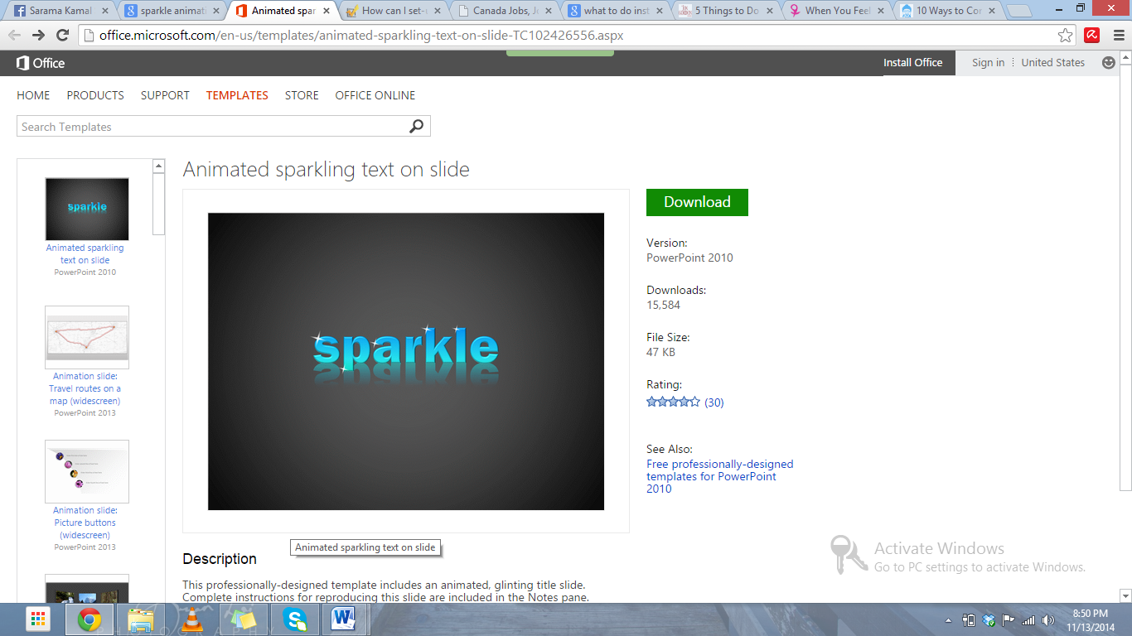

## **Lab Tasks**

**Task # 01:** Create a PowerPoint presentation with Title “My Software Product”, include the transitions, animations, images and the following headings should be included in the slides:

* 1. Problem statement
  2. Existing system
  3. Features
  4. Hardware Requirements/ Software Requirements
  5. Drawbacks

**Task # 02:** Create a PowerPoint presentation with Title “Dives Visualization”, and add the following features:

* On **slide 2** add a **column chart that shows the following information:**

|  |  |
| --- | --- |
| **Location** | **Number of Dives**  **this Year** |
| Red Sea | 1780 |
| Caribbean | 3280 |
| Thailand | 3387 |
| Hawaii | 2472 |
| Belize | 1398 |

* Make sure that the chart also includes the following:
  + The heading **‘Best Places to Dive’.**
  + Horizontal axis label of **‘Location’**. Vertical axis label of **‘Number of Dives this Year’**.
  + The **legend should be removed.**
* Position the chart in the space below the text **‘This chart shows the best places to dive:’**.

Save the presentation.